**[Gym management system]**

##### PROJECT Report

###### ***Submitted by***

**[A.NAVEEN (RA1911028010126)**

**K.SHIVA (RA1911028010133)**

**M.PRANAY (RA1911028010125)]**

***in partial fulfillment for the award of the degree***

***of***

**B.TECH**

*in*

# COMPUTER SCIENCE and ENGINEERING

**IN**

**CLOUD COMPUTING**

SRM INSTITUTE OF SCIENCE AND TECHNOLOGY

KATTANKULATHUR

##### [APRIL, 2022]

ABSTRACT

The Gym Management System is a simple PHP/MySQL project that manages a fitness gym business memberships and payments records. The system stores the fitness gym membership plans, packages, and trainers. The plan list helps organize the member’s selected plan for his/her membership with the fitness gym. Each plan is a one-time payment only, which means the membership fee of the members are based on their selected program, and this refers to how long the member will be marked as an active member in the fitness gym.

**TABLE OF CONTENT**

|  |  |  |
| --- | --- | --- |
| **CHAPTER NO** | **TITLE** | **PAGE NO** |
|  | **ABSTRACT** | 2 |
|  | **LIST OF TABLES** | 4 |
|  | **LIST OF ABBREVIATIONS** | 5 |
| **1** | **INTRODUCTION** | 6 |
| **2** | **Entity Relationship Diagram** | 7 |
| **3** | **Normalized Database Table** | 8 |
| **4** | **SQL Queries with results** | 9-16 |
| **5** | **Conclusion and Future Work** | 17 |
|  | **References** | 17 |

**LIST OF TABLES**

|  |  |  |
| --- | --- | --- |
| **TABLE NO** | **TITLE** | **PAGE NO** |
| 1  2  3 | MEMBERS  PACKAGES  PAYMENTS | 9  9  10 |
| 4 | PLANS |  |
| 5  6  7  8 | REG_INFO1  SCHEDULES  TRAINERS  USERS |  |

|  |  |  |
| --- | --- | --- |
|  |  |  |
|  |  |  |
|  |  |  |
|  |  |  |
|  |  |  |
|  |  |  |

|  |  |  |  |  |  |  |  |  |  |  |  |  |  |  |  |  |  |  |  |  |  |  |
| --- | --- | --- | --- | --- | --- | --- | --- | --- | --- | --- | --- | --- | --- | --- | --- | --- | --- | --- | --- | --- | --- | --- |
| **LIST OF ABBREVIATIONS**   |  |  | | --- | --- | | **Abbreviations** | **Description** | | # | Primary Key of an entity | | * | Normal Attribute | |  | Entity | |  | Relationship type | | A:B | Cardinality between entities | |  | Straight Relationship line | |  | Relationship arrow with head | |  |  | |  |  | |  |  |
|  |  |  |
|  |  |  |
|  |  |  |
|  |  |  |
| **INTRODUCTION:** |  |  |
|  |  |  |

You can contact us. As modernizing is taking over all the systems and digitalizing helps them improve in so many particular ways. The Gym Management System is one of the systems which helps the administration is speeding up the tasks at the same time reducing the complexity.

The purpose or objective of this system is to digitalize and create an automated system. The system will perform the task like adding the new member to the gym, Removing the member or keeping the payments records and other stuff required in managing the gym properly. The present scenario in the gyms is that the records are kept by writing in a file on paper. Every management task is done manually.

It helps in creating the various batch according to their preference or if they want a particular trainer. It made it easy to generate the reports of various operations performed in the gym are like paying the fee it can be stored and later evaluated and get the list of members who did not pay the fee. It also helps the users in reducing the carbon footprint as the amount of paper used in the company reduces.

This also helps in keeping the standard width of the management system as if there is a case where the administration involves more than one person to manage the gym. This system does not only limit itself to the administration and but also helps the members of the gym. The members can have options like attendance and fee payment change batch request etc.

This will improve the transparency between the members which is always a good quality in the system. It will also give a layer of security to the administration and the users that only authorized users can access by their credentials.

ER- DIAGRAM:-

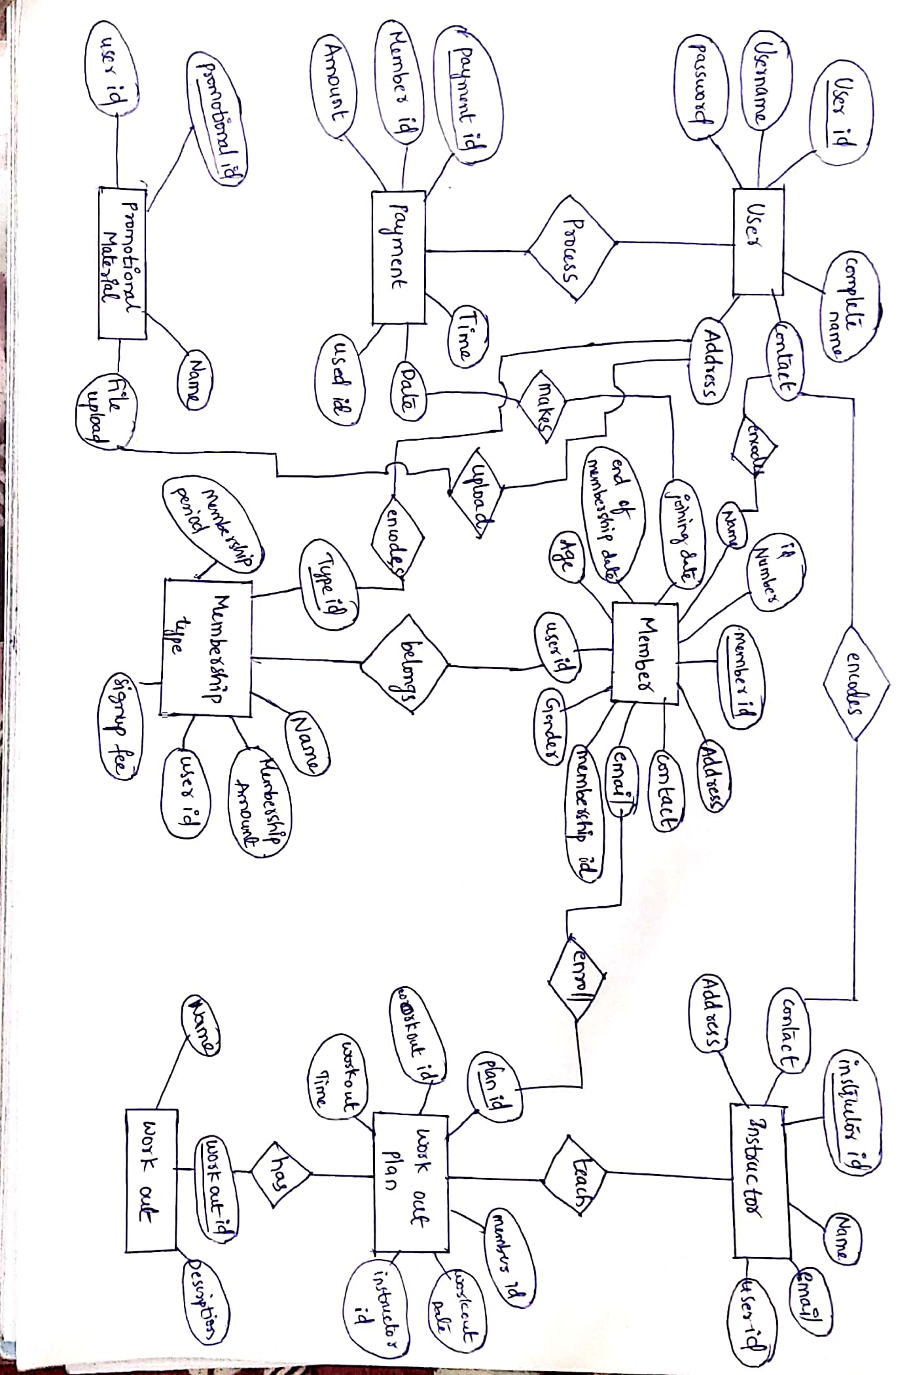

**NORMALIZED DATABASE TABLE**

When the above ER diagram is converted to relational model as we move from conceptual design to logical design we get 8 relations or tables. All these tables will be in 1NF as belong to RDBMS. In all these relations only the unique attribute reserves the ability to uniquely determine all the other prime as well as non-prime attributes.

**MEMEBERS:-**

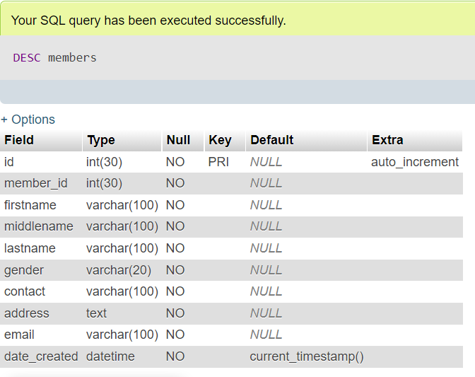

**PACKAGES:-**

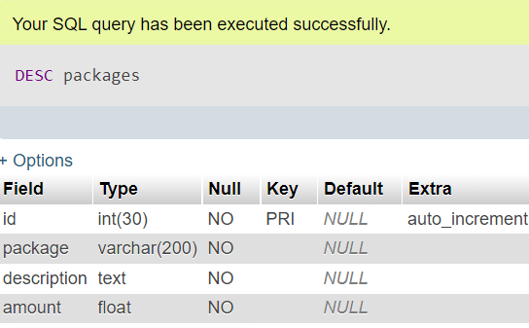

**PAYMENTS:-**

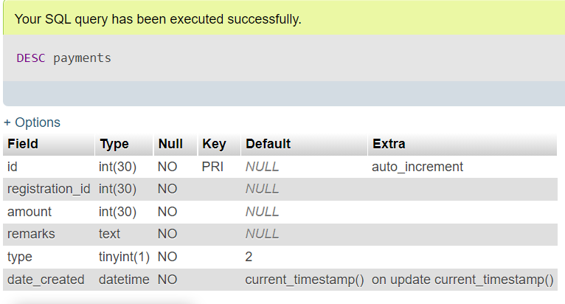

**PLANS:-**

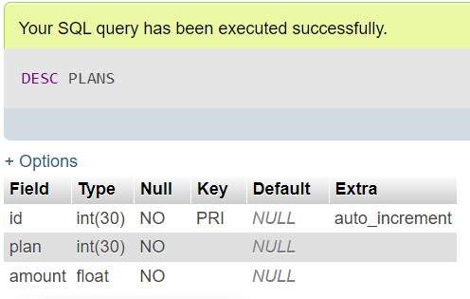

**REG_INFO:-**

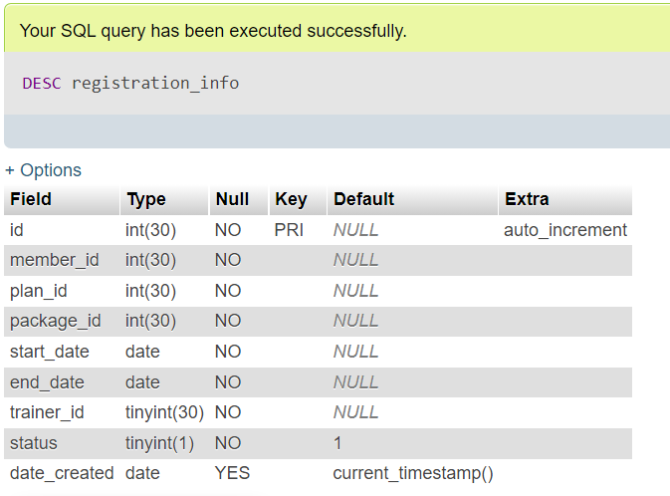

**SCHEDULES:-**

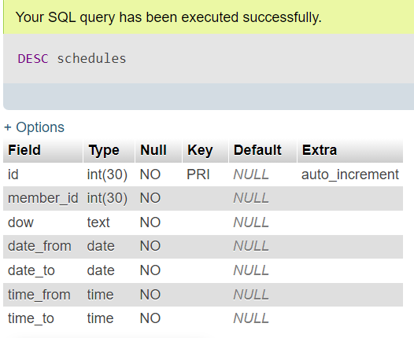

**TRAINERS:-**

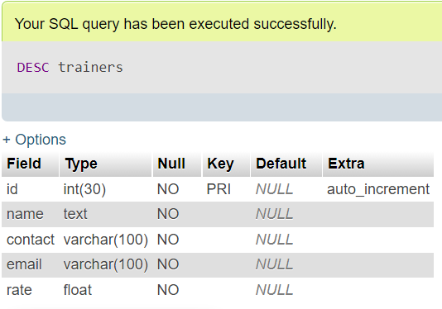

**USERS:-**

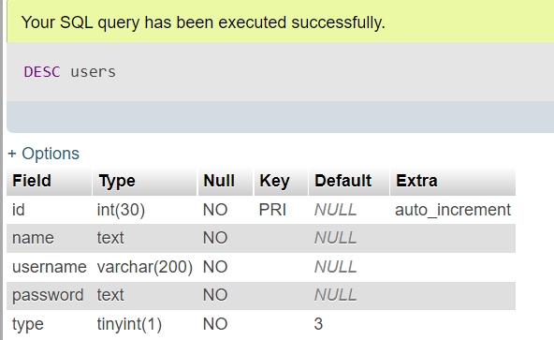

**SQL QUERIES WITH RESULTS:-**

CREATE TABLE `members` (

`id` int(30) NOT NULL,

`member_id` int(30) NOT NULL,

`firstname` varchar(100) NOT NULL,

`middlename` varchar(100) NOT NULL,

`lastname` varchar(100) NOT NULL,

`gender` varchar(20) NOT NULL,

`contact` varchar(100) NOT NULL,

`address` text NOT NULL,

`email` varchar(100) NOT NULL,

`date_created` datetime NOT NULL DEFAULT current_timestamp()

)

INSERT INTO `members` (`id`, `member_id`, `firstname`, `middlename`, `lastname`, `gender`, `contact`, `address`, `email`, `date_created`) VALUES

(5, 58487246, 'Mike', 'D', 'Williams', 'Male', '+14526-5455-44', 'Sample Address', 'mwilliams@sample.com', '2020-10-21 13:18:19'),

(6, 59430244, 'Claire', 'D', 'Blake', 'Female', '+18456-5455-55', 'Sample', 'cblake@sample.com', '2020-10-21 14:57:54');

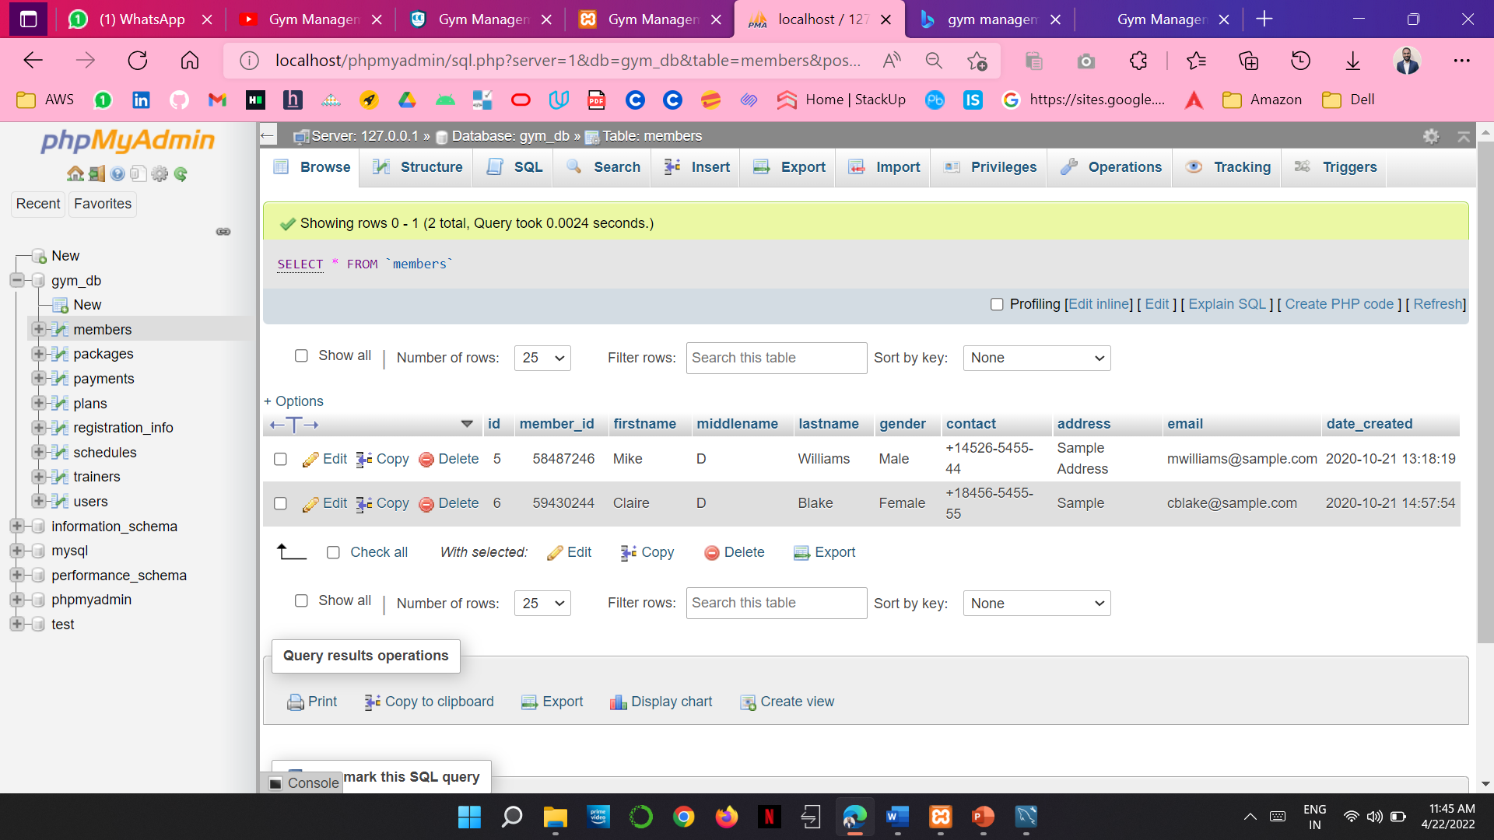

CREATE TABLE `trainers` (

`id` int(30) NOT NULL,

`name` text NOT NULL,

`contact` varchar(100) NOT NULL,

`email` varchar(100) NOT NULL,

`rate` float NOT NULL

)

INSERT INTO `trainers` (`id`, `name`, `contact`, `email`, `rate`) VALUES

(1, 'John Smith', '+18456-5455-55', 'jsmith@sample.com', 500);

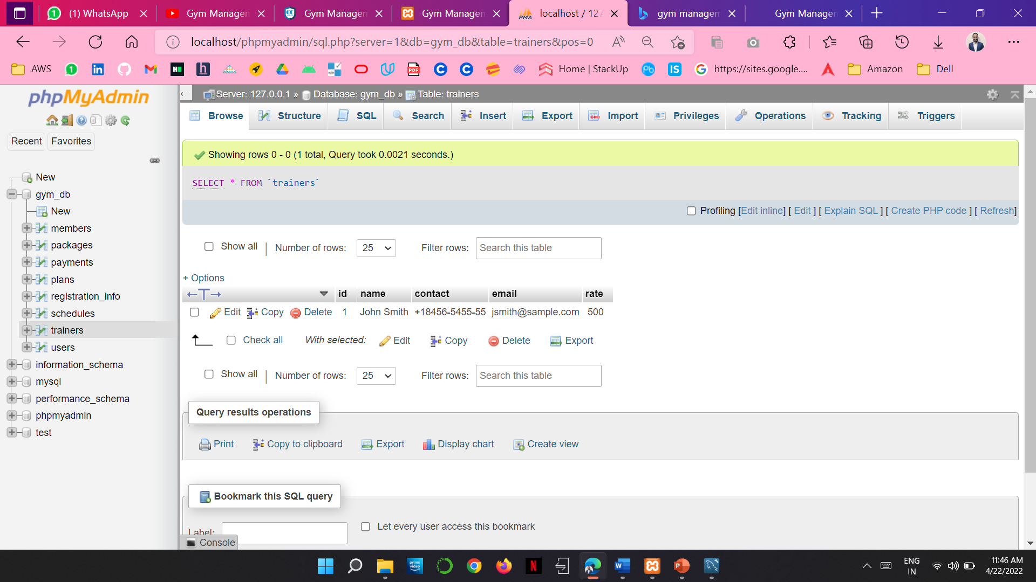

**CONCLUSION:-**

The gym system works efficiently as a gym management system. It is robust and will not crash while running in the event of user input error or user misuse. The system could be expanded to cater for large gyms. There is no limit to the amount of information that this system can hold. This system holds information about gym members, employees, equipment and also fitness classes. Information can also be removed at any time from the system. This project has proven to be a worthwhile exercise in software development from inception to planning and execution of the code

**FUTURE SCOPE:-**

The system may be further updated or modified at will owing to its simple structure. We can further add a diet plan . Depending on future requirements more changes can be made owing to the organization’s need.

**REFERNCES:-**

GITHUB LINK:

[AtlaNaveen/DBMS-Mini-Project-18CSC303J (github.com)](https://github.com/AtlaNaveen/DBMS-Mini-Project-18CSC303J)